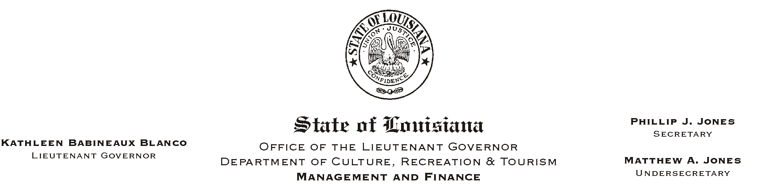

HUMAN RESOURCES MEMORANDUM NO. 03-064

July 25, 2003

TO: Lt. Governor, Secretary, Undersecretary, Assistant Secretaries, Deputy Assistant Secretaries, Program Managers

FROM: Mary F. Ginn
Human Resources Director

SUBJECT: A Lunch and Learn Workshop - "Eating Healthy"
(Another in our series of informational meetings on health, safety, & well being.)

"Eating Healthy"
Nutritionists Angelina Stratton, LDN, RD and Nancy Kora, LDN, RD
Pennington Biomedical Research Center
Tuesday, August 12, 2003, 11:30 a.m. - 1:00 p.m.
Seminar Center, State Library

LOSE 20 POUNDS IN 48 HOURS!!! Did this catch your attention? No, the department is not sponsoring a weight loss program, but as part of our continuing effort in promoting a safe and healthy workplace, we have invited two top nutritionists, Nancy Kora and Angelina Stratton, from the Pennington Biomedical Research Center for another Lunch & Learn Workshop. These nutritionists will give a presentation on fad diets and developing a healthy eating lifestyle. This is sure to be a crowd pleaser, so sign up today.

Please complete the attached registration form and submit it to the Human Resources Office or register on-line on “Channel Z” no later than 12:00 noon on August 8, 2003. Employees can purchase lunch from Bonanno’s Fine Catering or bring their own lunch.

Attachment

Please Post and Circulate
A “LUNCH AND LEARN” WORKSHOP
"Eating Healthy"
Nutritionists Angelina Stratton, LDN, RD and Nancy Kora, LDN, RD
Tuesday, August 12, 2003, 11:30 a.m. - 1:00 p.m.
Seminar Center, State Library

REGISTRATION FORM

Please Print
Name_________________________________________________________________________
Department________________________________________ Phone #____________________

____ Include me in the Buffet Lunch of Tossed Greens with Assorted Fresh Fruit, Tossed Caesar Salad with Grilled Chicken, Pasta Salad with Grilled Vegetables, and Cookies – Approximately $4.50*

*Price is contingent on the number of employees ordering lunch.

IMPORTANT: If you are unable to attend after making a reservation and fail to notify us, please understand that we must consider this registration a guarantee for your payment.

Payment Choice:

_____ I will pay at the meeting (please pay by check).

OR
_____ I will attend the presentation but will not participate in the lunch.

Signatures:

EMPLOYEE______________________________Date__________________
SUPERVISOR_____________________________Date__________________

