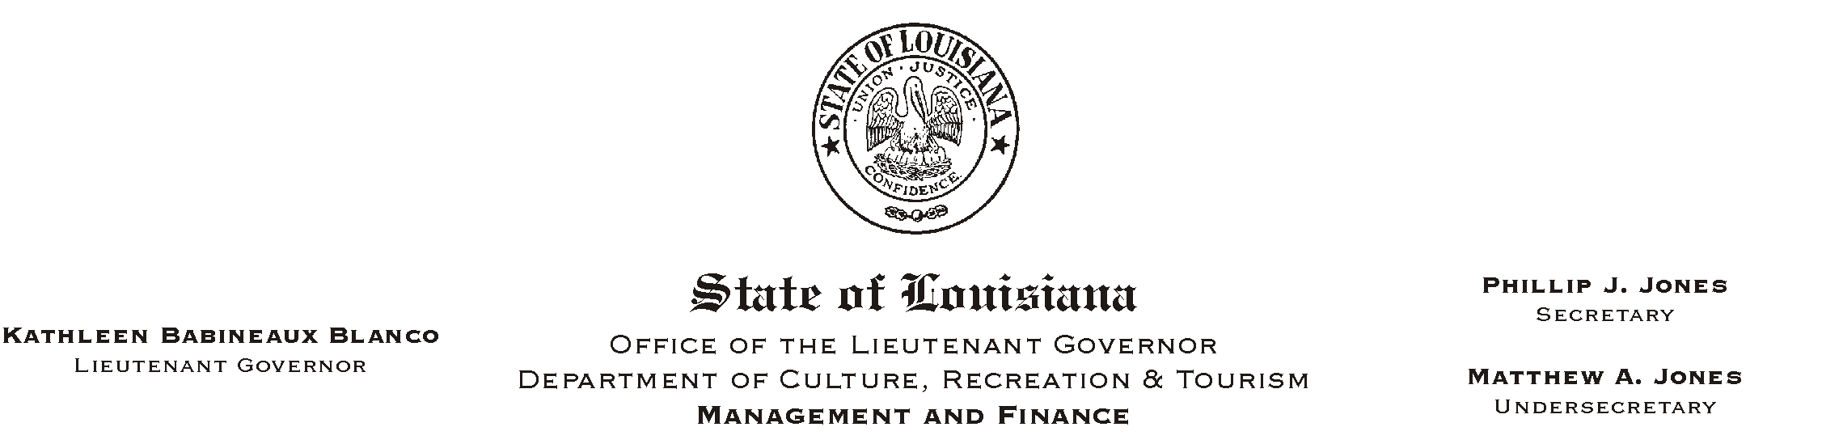

HUMAN RESOURCES MEMORANDUM NO. 03-067

August 11, 2003

TO: Lt. Governor, Secretary, Undersecretary, Assistant Secretaries, Deputy Assistant Secretaries, Program Managers

FROM: Mary F. Ginn
Human Resources Director

SUBJECT: Unscheduled Absenteeism Policy

Frequent, unscheduled absenteeism is a significant obstacle to good employee morale and productivity in state government. Often, co-workers must perform the duties of the absent employee. In order to encourage the responsible use of leave by employees, the department has adopted a policy on Unscheduled Absenteeism beginning September 1, 2003. This policy was approved by the State Civil Service Commission on August 6, 2003. The policy provides for the non-disciplinary removal of an employee who has more than nine (9) unscheduled absences during any consecutive 26-week period. Prior to September 1, 2003, please educate all employees about the policy, post it in a central location, and return the employee acknowledgment forms to our office for retention in the employee personnel files.

Civil Service Rule 12.6 “Non-disciplinary Removals,” section (a) “Absence from Work,” subsection 2, is the authority under which this policy was developed. The rule is published in the policy. However, please note that subsection (a) 1 is not included in the policy because it refers to the removal of an employee for exhausting sick leave and is not applicable to this policy.

An “unscheduled absence” is defined as an employee’s failure to report for duty without having advance permission from an authorized supervisor. Some of our agencies have defined what is acceptable advance permission in their “call-in” policies. Agencies with “call-in” policies should review those policies with employees when this policy is presented. Agencies that have no “call-in” policy or that have not defined acceptable time periods for requesting leave in advance must do so before September 1, 2003.

Appointing authorities who have not previously done so must set policies to establish the minimum period of an absence that will be used to determine an occurrence under the policy. All agencies must define what is acceptable advance permission for leave and clearly communicate this information to all employees along with this policy before September 1, 2003.

Human Resources Memorandum No. 03-067
August 11, 2003
Page 2

When an employee is in violation of this policy, the employee must receive notice, in writing, within five workdays of each unscheduled absence declaring the absence to be an occurrence under this policy. This notice must also include the number of occurrences accumulated thus far within the consecutive twenty-six (26) week period. The notice must also inform the employee of the manner in which the absence was coded (annual, sick, compensatory, or leave without pay). Please carefully review the policy for other details.

An employee can only be removed under the authority of this policy by the proper appointing authority. As with any disciplinary or removal action, supervisors must contact the HR Director for guidance. The HR Director will provide assistance with the preparation of a pre-termination notice in which the employee will be given advance notice outlining the reason for the action, a description of the evidence, and a reasonable opportunity to respond.

If you have any questions, please contact the Human Resources Office at (225) 342-0880.

Attachments
Please Post and Circulate

