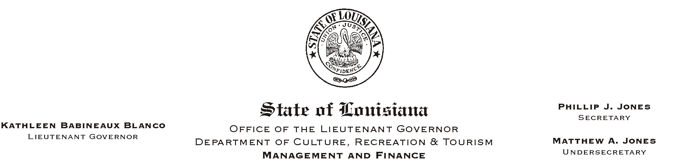

HUMAN RESOURCES MEMORANDUM NO. 03-069

August 11, 2003

TO: Lt. Governor, Secretary, Undersecretary, Assistant Secretaries, Deputy Assistant Secretaries, Program Managers

FROM: Mary F. Ginn
Human Resources Director

SUBJECT: Restrictions on Certain Appointments During Gubernatorial Election

This is a reminder to all managers and appointing authorities concerning restrictions on certain appointments during gubernatorial election time. Civil Service Rule 8.2.1 states: “From the date of the gubernatorial first primary election through Inauguration Day, specific approval must be obtained from the (Civil Service) Director prior to making a permanent appointment to any position at or above one of the following pay ranges: GS-23, AS-620, SS-419, PS-115, WS-218, TS-315, unless the position has already been designated as a Shortage job, under Rule 7.20(d).”

If you have any questions concerning this rule, please do not hesitate to call the Human Resources Office at (225) 342-0880.

Please Post and Circulate

