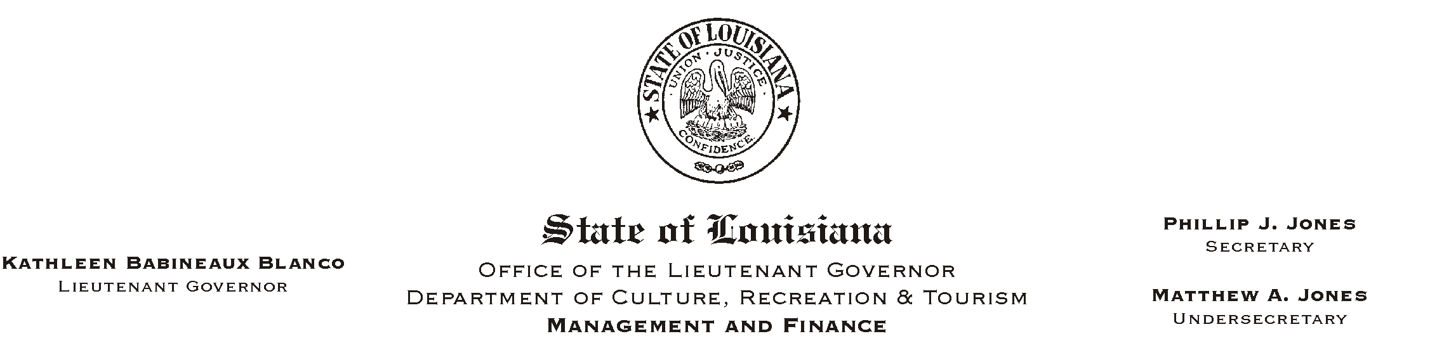

HUMAN RESOURCES MEMORANDUM NO. 03-070

August 12, 2003

TO: Lt. Governor, Secretary, Undersecretary, Assistant Secretaries, Deputy Assistant Secretaries, Program Managers

FROM: Mary F. Ginn
Human Resources Director

SUBJECT: Important Payroll Issues That Cause Potential Losses to the Department

Managers are reminded of the importance of accurate and timely submissions of OMF-301 forms and time sheets for separated employees. We are experiencing situations where employees are being over or underpaid due to incorrect termination dates on 301 forms and time entries made after a resignation/termination date. Underpayments can be remedied by issuing supplemental payments; o verpayments have far more consequences and can cause losses to the department.

It is the responsibility of managers to insure that timekeepers have accurate information entered into the system before payroll runs at the end of each pay period. But in the event that changes occur after the pay period has ended, it is vital that the corrections be made immediately. When an error is discovered on the Monday after the pay period ends, corrections can be made before a check (deposit) is issued. When an error is discovered after Monday, if early enough, we can make the corrections by requesting a “stop payment” through the Division of Administration and issuing a corrected check (deposit). To do this, managers must immediately call in the corrections to the HR Office and follow up with an approved Prior Pay Period Adjustment (PPA). We must receive the PPA paperwork no later than the following pay period.

If a separated employee receives an overpayment, it must be recouped. If the employee does not voluntarily refund the money to the department, we must recoup the losses through written requests or the legal system.

Once again, this is a very important issue. If you have any questions, please contact the Human Resources Office at (225) 342-0880.

Please Post and Circulate

