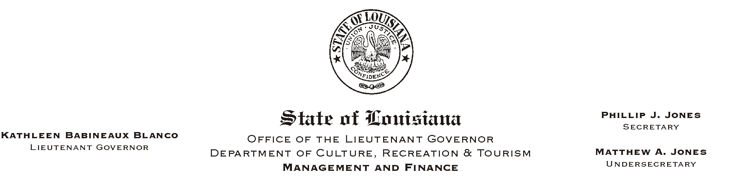

HUMAN RESOURCES MEMORANDUM NO. 03-072

August 15, 2003

TO: Lt. Governor, Secretary, Undersecretary, Assistant Secretaries, Deputy Assistant Secretaries, Program Managers

FROM: Mary F. Ginn
Human Resources Director

SUBJECT: Revised New Hire Orientation Checklist and Policy Acknowledgment Form

A few days ago, the new Unscheduled Absenteeism Policy, effective September 1, 2003, was issued by HR Memo No. 03-067. Managers were asked to educate all current employees about the policy, post the policy in a central location, and to return the employee acknowledgment forms to the Human Resources Office for retention in employees’ personnel files.

This memo is to notify all field offices that are authorized to conduct new hire orientation at the sites to begin immediately incorporating the Unscheduled Absenteeism Policy into their orientation programs. The New Hire Orientation Checklist and the Employee Policy Acknowledgments forms have been revised to include the new policy and are attached. Please replace all outdated documents with the new ones.

Agencies authorized to send their new employees for orientation in Baton Rouge with Human Resources staff, should consider this memo as informational only.

If you have any questions, please call the Human Resources Office at (225) 342-0880.

Attachments

Please Post and Circulate

