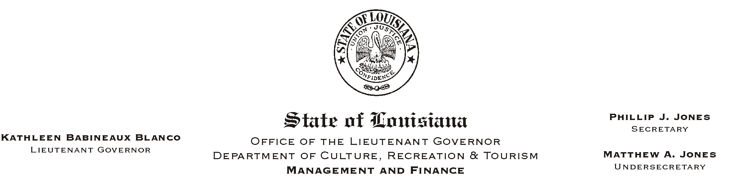

HUMAN RESOURCES MEMORANDUM NO. 03-073

August 25, 2003

TO: Lt. Governor, Secretary, Undersecretary, Assistant Secretaries, Deputy Assistant Secretaries, Program Managers

FROM: Mary F. Ginn
Human Resources Director

SUBJECT: Labor Day Holiday and Payroll Deadline

Monday, September 1, 2003, is a holiday for state employees. Because the holiday falls on a payroll-ending week, all payroll information for the pay period ending August 31, 2003, must be received in the Human Resources Office no later than Wednesday, August 27, 2003. This deadline also applies to employees who need to update their payroll or benefits information (i.e., Federal tax withholding, direct deposit authorizations, insurance, address, etc.) during this pay period.

If you have any questions, please call the Human Resources Office at (225) 342-0880.

Please Post and Circulate

