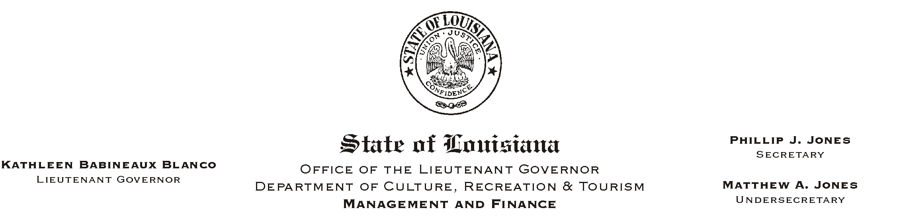
August 28, 2003
HUMAN RESOURCES MEMORANDUM NO. 03-075

TO: Lt. Governor, Secretary, Undersecretary, Assistant Secretaries, Deputy Assistant Secretaries, Program Managers, and All Employees

FROM: Mary F. Ginn
Human Resources Director

SUBJECT: “All American Lunch” – To Commemorate the Events of 9/11/01
Please Post and Circulate

Employees are invited to join together for our second annual “All American Lunch” to commemorate the events of 9/11/01 when “the best of humanity met the worst of humanity.” Father Jeffery Bayhi will begin our commemorative event with a prayer and words of hope. State Museum Police Officer Carl Dennis will sing “The National Anthem” and “God Bless America.”
Donations to the American Red Cross will be accepted during the event.

All American Lunch Includes
BBQ Chicken, Potato Salad, Baked Beans, Garlic Bread, Drink, and Apple Pie A-La-Mode
Thursday, September 11, 2003, 11:30 a.m.
Capitol Annex Lobby - First Floor
Approximately $7.00 per person, Pre-Registration Required
NOTE: Final amount will be determined after registrations are in. Registrants will be notified by e-mail. If you are unable to attend after making a reservation and fail to notify us, please understand that we must consider this registration a guarantee for your payment. Please pay at the door with the correct cash amount or by check made out to cash.

To register, please fax this form to (225) 342-7928 or hand deliver to the HR Office no later than 11:00 a.m., Tuesday, September 9 or register on Channel Z.

PRINT NAME_______________________________________AGENCY____________________

PHONE #________________________________E-MAIL _______________________________

_____________________________________________________________________________
Employee Signature Date

