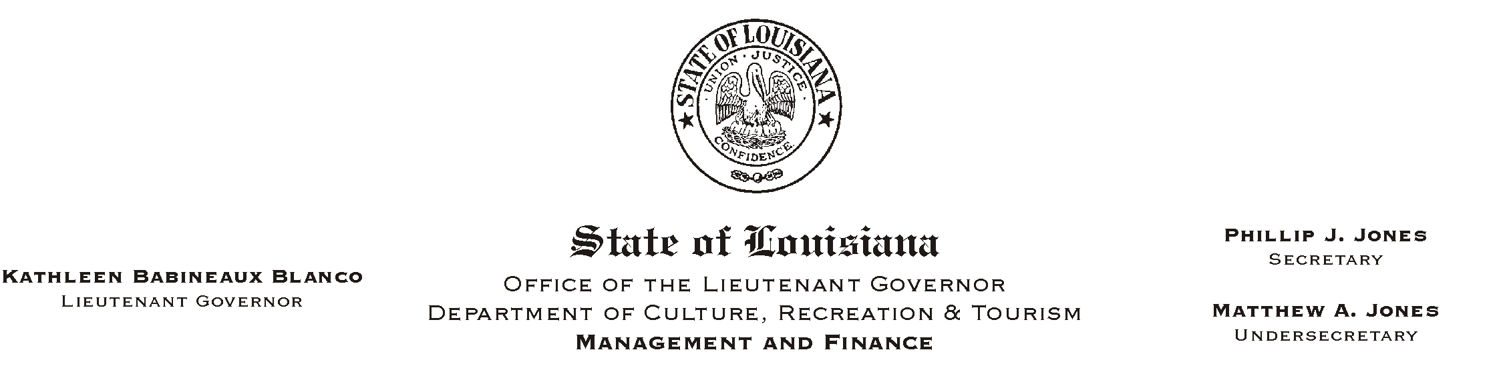

HUMAN RESOURCES MEMORANDUM NO. 03-076

September 9, 2003

TO: Lt. Governor, Secretary, Undersecretary, Assistant Secretaries, Deputy Assistant Secretaries, Program Managers

FROM: Mary F. Ginn
Human Resources Director

SUBJECT: Fall Book Fair

On Friday, September 19, 2003, in conjunction with Books Are Fun, Ltd. we will be sponsoring a book fair to benefit the Capital Area United Way. The book fair will be held in the lobby of the Capitol Annex on the 1st floor from 8:00 a.m. until 3:30 p.m.

Quality, hardcover titles in over 12 categories will be available for purchase at up to 70% off retail prices including:

New York Times Best-Sellers
Children’s Storybooks and Classics
Children’s Educational Books
Home and Gardening Books
Cookbooks
Inspirational and Multi-Cultural Books
Gift Items and Music CDs
Sports and Health Books

Please plan to stop by and purchase some great books!

Please Post and Circulate

