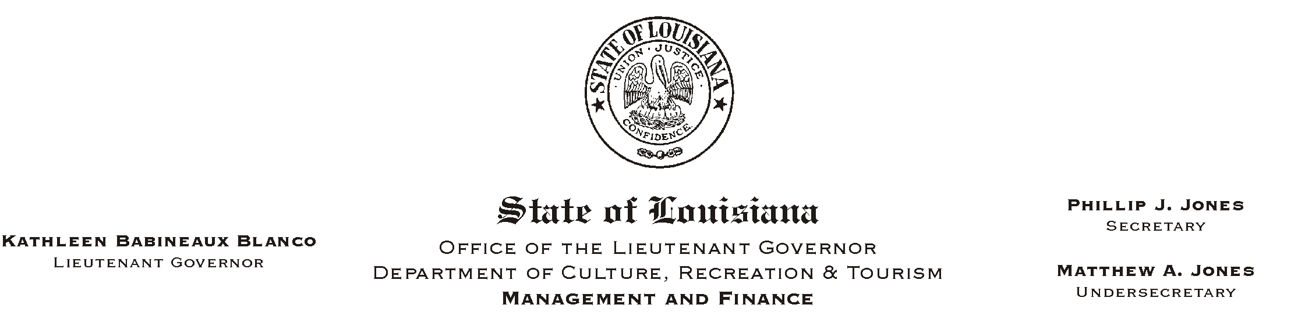

HUMAN RESOURCES MEMORANDUM NO. 03-077

September 9, 2003

TO: Lt. Governor, Secretary, Undersecretary, Assistant Secretaries, Deputy Assistant Secretaries, Program Managers

FROM: Mary F. Ginn
Human Resources Director

SUBJECT: Amended Civil Service Pay Rules

In conjunction with the creation and adoption of the six different pay schedules, Governor Mike Foster has approved several changes to the Civil Service pay rules regarding pay upon market grade adjustment, promotion, reallocation, demotion, and job correction or grade assignment. These rules will be effective on September 9, 2003.

The rules that were amended and adopted are attached for your information only. We will continue to calculate any pay changes in the Human Resources Office.

Attachment

Please Post and Circulate
Amended Civil Service Rules

Rule 6.6 Market Grade Adjustment

(a) When the pay range for the grade to which a job is currently assigned is either not sufficient to compete with prevailing market conditions, or is found to exceed prevailing market rates, the Director may, in accordance with Rules 6.1 and 3.1(n), authorize the assignment of the job to a grade with a more appropriate pay range. The individual pay rate of employees occupying jobs which are affected shall be set in accordance with Rule 6.8.1.

(b) Repealed, as of December 4, 1989.

Rule 6.7 Rate of Pay Upon Promotion

(a) No change.

(b) No change.

(c) No change.

(d) When an employee has been detailed with pay to a higher job and is promoted to that same job or a job at the same pay level or a higher pay level directly from the detail, his pay eligibility on promotion shall not be less than he received on detail.

(e) Subject to the provisions of subsection (f) of this rule, when an employee is promoted from a job assigned to one pay schedule to a job with a higher range maximum in another pay schedule, his pay shall be adjusted as follows:

1. If the maximum of the job to which he is being promoted is less than 14% above his current maximum, his pay shall be increased by 7%.

2. If the maximum of the job to which he is being promoted is at least 14% but less than 21% above his current maximum, his pay shall be increased at least by 7% but not to exceed 10.5%.

3. If the maximum of the job to which he is being promoted is equal to or greater than 21% above his current maximum, his pay shall be increased by at least 7% but not to exceed 14%.

(f) No change.

Rule 6.8 Pay Upon Reallocation

When the Director changes the allocation of a position from one job to another by reallocation,

(a) If the job to which the position is allocated is in a higher grade in the same schedule or is in a grade with a higher maximum in another schedule, the affected employee's pay shall be set in accordance with Rule 6.7.

(b) Subject to the provisions of subsection (d) of this rule, if the job to which the position is allocated is in a lower grade in the same schedule or is in a grade with a lower maximum in another schedule, the affected employee's pay will not change, but shall be subject to provisions of Rule 6.15.

(c) Subject to the provisions of subsection (d) of this rule, if the job to which the position is allocated is in the same grade in the same schedule or is in a grade with the same maximum in another schedule, the employee's pay shall not change.

(d) If the position is reallocated in such a way that the current base supplement rate of pay authorized for the position is lost or reduced, the affected employee's pay shall be set no higher than his current salary and at the higher of the following:

1. the range maximum (this is a red circle rate) of the position from which he is being reallocated, or

2. within the range maximum plus the base supplement (this is not a red circle rate) authorized for the position to which he is to being reallocated.

Rule 6.8.1 Pay Upon Job Correction or Grade Assignment (New)

When the Director assigns a job to a different grade or changes the allocation of a position from one job to another by job correction,

(a) If the job to which the position is job corrected is in a higher grade in the same pay schedule or is in a grade with a higher range maximum in another pay schedule, or if the job is assigned to a higher grade in the same pay schedule or to a grade with a higher range maximum in another schedule, the affected employee's pay shall not change. An employee shall not be paid below the minimum of the higher range.

b) Subject to the provisions of subsection (d) of this rule, if the job to which the position is job corrected is in a lower grade in the same pay schedule or is in a grade with a lower range maximum in another pay schedule, or if the job is assigned to a lower grade in the same pay schedule or to a grade with a lower range maximum in another schedule, the affected employee's pay shall not change, but shall be subject to provisions of Rule 6.15.

(c) Subject to the provisions of subsection (d) of this rule, if the job to which the position is job corrected is in the same grade in the same pay schedule or is in a grade with the same range maximum in another pay schedule, or if the job is assigned to the same grade in the same pay schedule or to a grade with the same range maximum in another schedule, the affected employee's pay shall not change

(d) If the position is job corrected or if a job has a pay range change in such a way that the current base supplement rate of pay authorized for the position is lost or reduced, the affected employee's pay shall be set no higher than his current salary and at the higher of the following:

1. the range maximum (this is a red circle rate) of the position from which he is being changed, or

2. within the range maximum plus the base supplement (this is not a red circle rate) authorized for the position to which he is to be changed.

6.10 Rate of Pay Upon Demotion

Subject to the provisions of Civil Service Rules 6.15 and 17.11(a) and (b) 2, when an employee is demoted for any reason under any circumstances, his pay shall be reduced as follows:

(a) If the demotion is to a job within the same schedule or to a job in another schedule with a lower maximum his pay shall be reduced by a minimum of 7% and may be set at a lower rate in the range provided that it is no less than the minimum.

(b) Repeal.

(c) Repeal.
(d) Subject to the provisions of Rule 6.29, an appointing authority may grant exceptions to this rule for voluntary demotions. Exceptions shall not by granted by the appointing authority in an arbitrary or fraudulent manner designed to increase an employee’s rate of pay. An appointing authority may, as part of a formal written policy, waive a pay increase on promotion for an employee who has been demoted without a decrease in pay within a six-month period.

