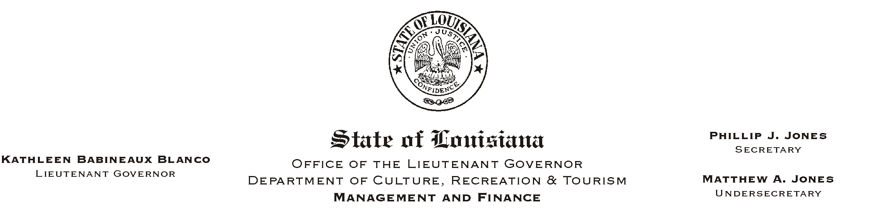

HUMAN RESOURCES MEMORANDUM NO. 03-079

September 9, 2003

TO: Lt. Governor, Secretary, Undersecretary, Assistant Secretaries, Deputy Assistant Secretaries, Program Managers

FROM: Mary F. Ginn
Human Resources Director

SUBJECT: “Act of God” Leave Request Form

Civil Service Rule 11.23(d) provides for an appointing authority to direct the closure of a facility or site when extreme emergencies such as hurricanes or floods prevent employees from performing their jobs. The attached “Act of God” Leave Request Form must be completed when a facility or site is closed under these circumstances.

When a work closure occurs because of an Act of God, employees who are instructed to stay at home will be entitled to special leave that is coded LSAG. This leave must be recorded on the attached form. Employees who are required to come to work during this period will earn non-payable compensatory time that must also be recorded on the form. See the attached example for filling out the form. Employees earning compensatory time during this period must also complete a Compensatory Request Form for payroll backup.

If you have any questions, please contact the Human Resources Office at (225) 342-0880.

Attachments

Please Post and Circulate

