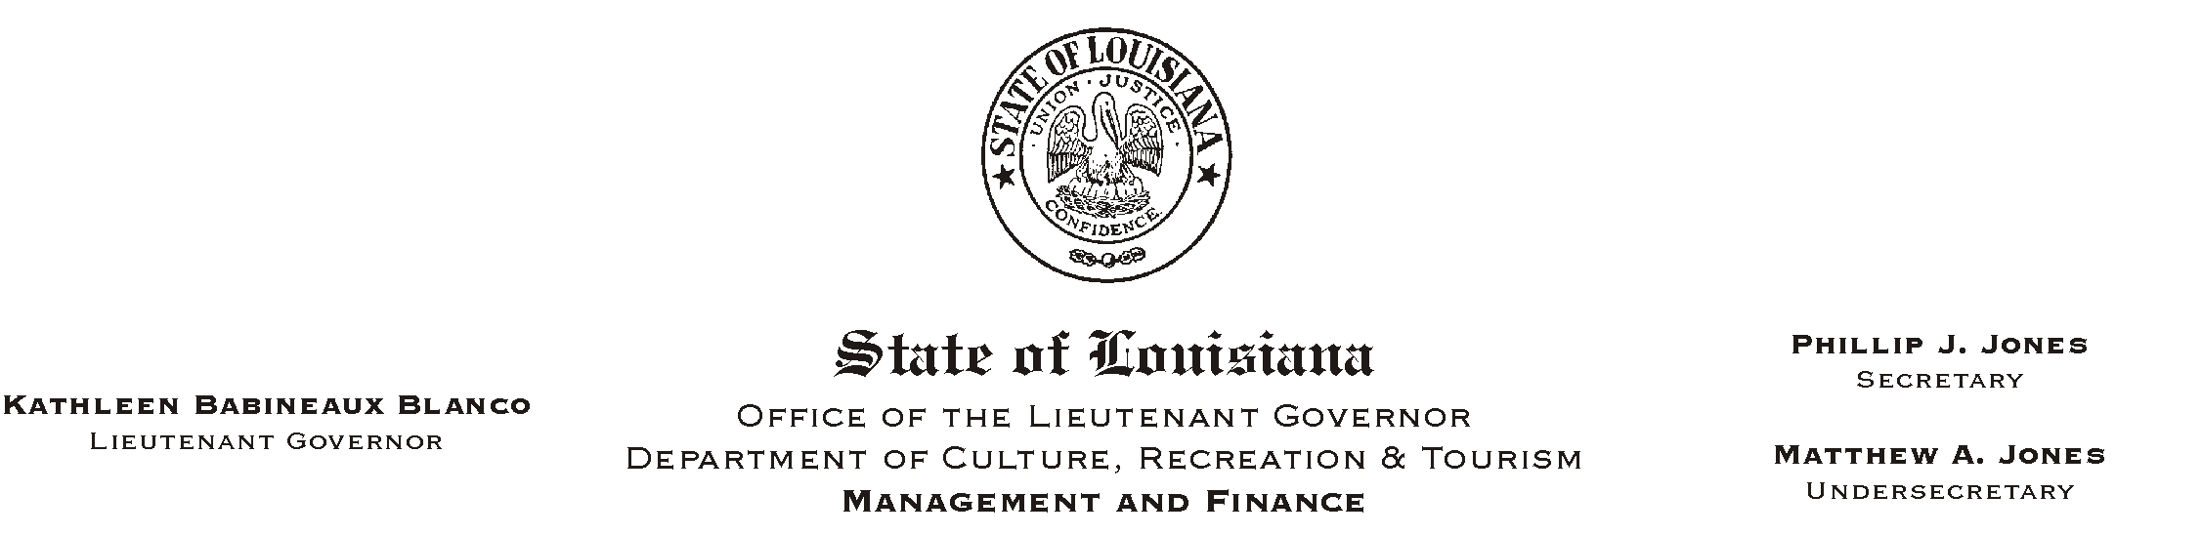

HUMAN RESOURCES MEMORANDUM NO. 03-091

October 20, 2003

TO: Lt. Governor, Secretary, Undersecretary, Assistant Secretaries, Deputy Assistant Secretaries, Program Managers

FROM: Mary F. Ginn
Human Resources Director

SUBJECT: Louisiana Employees Online (LEO) Available November 12, 2003

Many of you are familiar with Employee Self Service (ESS) and use the system regularly to look at your check statements and other information. But because ESS has encountered problems in the past and generated so many complaints, the Division of Administration has established a new portal for employee self-service, providing improvements to the current system and the opportunity for future expansion.

The first phase of the new Louisiana Employees Online (LEO) will be implemented on November 12, 2003, offering basic functions: pay statement information; benefits plans; emergency contact information; and state employee directory. Future plans include advanced functions for employees to make changes to their address, bank, and tax withholding information; and more.

We will be viewing a demonstration of the new system later this month and will be ready to assist employees with the new system when it becomes available in mid-November. A flier is attached for posting and distribution.

If you have any questions, please call the Human Resources Office at (225) 342-0880.

Attachment

Please Post and Circulate

