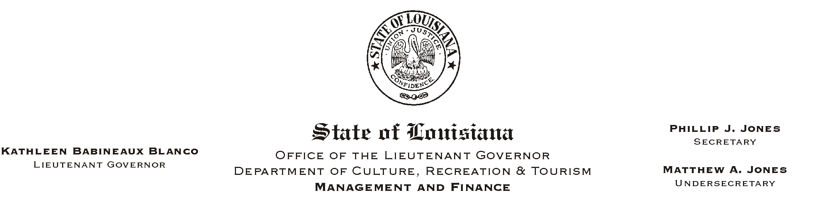

HUMAN RESOURCES MEMORANDUM NO. 03-093

October 21, 2003

TO: Lt. Governor, Secretary, Undersecretary, Assistant Secretaries, Deputy Assistant Secretaries, Program Managers

FROM: Mary F. Ginn
Human Resources Director

SUBJECT: Timekeeping Update: Method of Charging Annual and Sick Leave

The ISIS payroll system was designed to round employees’ minimum leave usage to the nearest tenth of an hour (one decimal place) because of Civil Service Rule 11.7 requiring that employee’s leave records not be charged less than one-tenth hour (6 minutes or .1). Therefore, if a timekeeper entered 1.24 LA, 1.2 hours were deducted from the employee’s leave balance. If 1.25 LA was entered, 1.3 hours were deducted.

The ISIS HR Influence Group recently asked Civil Service for a ruling on whether this rounding process was appropriate or whether entries to the hundredths of an hour should be allowed. Civil Service ruled that any portion of an absence in excess of six minutes could be credited using two decimal places (hundredth of an hour), but that entries of less than 6 minutes were still prohibited, i.e. 0.08 (5 minutes) is not allowed.

As a result of this ruling, the ISIS payroll system no longer rounds leave taken to the tenth of an hour. Timekeepers may enter leave taken to the hundredth of an hour (equal to or greater than 0.10) but never less than 6 minutes (never less than 0.10 of an hour) for a single absence. Even though the ISIS system will accept less than 6 minutes, it is not allowed.

Please Post and Circulate
Please forward this information to all timekeepers. If you have any questions, contact the Human Resources Office at (225) 342-0880.

