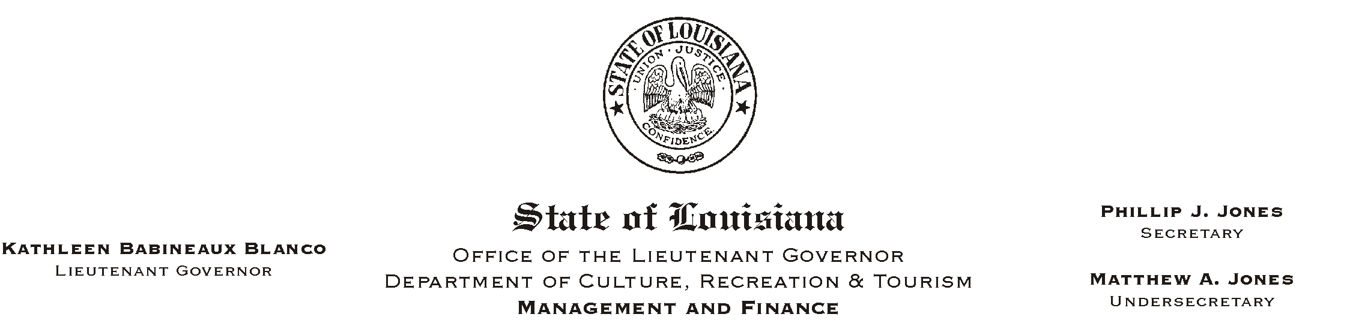

HUMAN RESOURCES MEMORANDUM NO. 03-095

October 31, 2003

TO: Lt. Governor, Secretary, Undersecretary, Assistant Secretaries, Deputy Assistant Secretaries, Program Managers

FROM: Mary F. Ginn
Human Resources Director

SUBJECT: Upcoming Holidays

The following is a list of upcoming holidays. Some of the holidays are statutory and others have been proclaimed by the Governor.

November 11 Veterans’ Day Statutory

November 27 Thanksgiving Day Statutory
November 28 Acadian Day Proclaimed

December 25 Christmas Day Statutory
December 26 Day After Christmas Proclaimed

January 1 New Year’s Day Statutory
January 2 Day After New Year’s Proclaimed
January 12 Inauguration Day (Only in the city limits of Baton Rouge)

Please Post and Circulate

Please notify all employees. If you have any questions, please call the Human Resources Office at (225) 342-0880.

