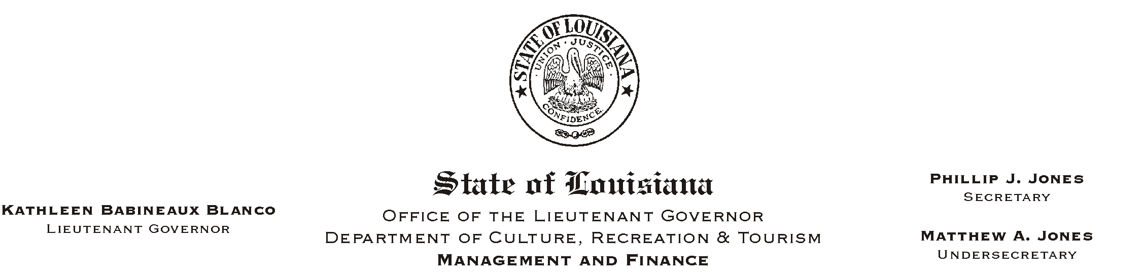

HUMAN RESOURCES MEMORANDUM NO. 03-099

November 11, 2003

TO: Lt. Governor, Secretary, Undersecretary, Assistant Secretaries, Deputy Assistant Secretaries, Program Managers

FROM: Mary F. Ginn
Human Resources Director

SUBJECT: Timekeeping Audits to Begin

HR/Payroll Staff will begin auditing agency timekeeping records and procedures on November 19, 2003. Timekeepers will be notified of the time and location in advance of the audits. During the audits, HR/Payroll Staff will be checking for the following:

Agency Written Time and Attendance Policies
Agency Written Procedures, Assignments, Guidelines, or other Job Aids
Timesheets, Leave Slips, and Overtime Approvals
Agency ISIS Time Entry Auditing Reports
Evidence of Leave Balance Reports Sent to Management
Agency Prior Pay Period Adjustments and Audit Records
Work Schedule Changes
Proper Separation of Duties

At the time of the audits, other applicable documents and information may be requested.

When the audits have been completed, a report will be sent to each appointing authority. Please be
reminded that we are required to conduct audits in order to identify any errors and omissions in our system and to take corrective action. After this audit is completed, subsequent audits will be conducted on a random basis by HR/Payroll Staff and by the Internal Auditor.

If you have any questions, please call the Human Resources Office at (225) 342-0880.

