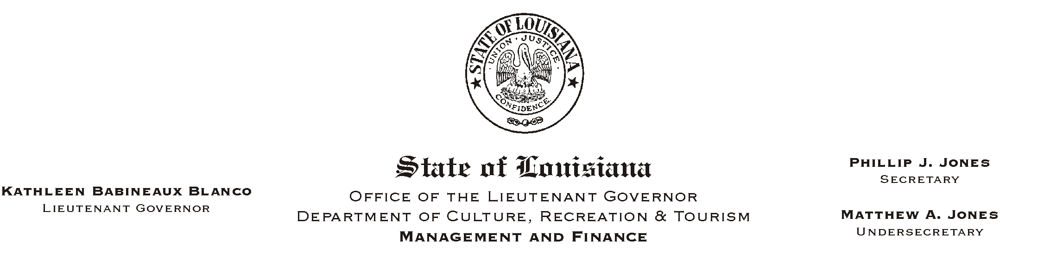

HUMAN RESOURCES MEMORANDUM NO. 03-102

November 26, 2003

TO: Employees of the Lieutenant Governor’s Office and CRT Employees in the Capital Area Parishes of United Way

FROM: Mary F. Ginn
Human Resources Director

SUBJECT: United Way Final Report

We did it once again! Thanks to all of you, our campaign was a success and lots of fun.

The following is a breakdown of our total contributions:

Pledges $6,064.24
One-time Cash Donations 405.00
Special Events
 Book Fair March 2003 240.74
 Book Fair September 2003 308.90
- White Elephant Auction 959.00
- White Elephant Auction Lunch 258.89
- Jambalaya Cookout 1,052.00
- Silent Auction 1,579.00
Raffle Baskets 785.00
 Casual Monday, Bake Sale, & Book Sale 538.78
 Art Sale 220.58
 Prints-Raffle 121.00

TOTAL $12,533.13

Please Post and Circulate

