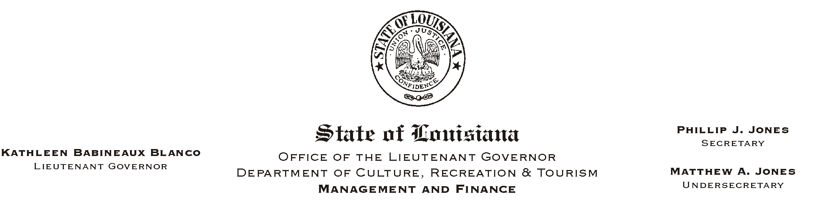

HUMAN RESOURCES MEMORANDUM NO. 03-104

December 15, 2003

TO: Lt. Governor, Secretary, Undersecretary, Assistant Secretaries, Deputy Assistant Secretaries, Program Managers

FROM: Mary F. Ginn
Human Resources Director

SUBJECT: New Year’s Holiday and Payroll Deadline

Our New Year’s holidays, Thursday and Friday, January 1-2, 2004, fall on a payroll-ending week. Therefore, all payroll information for that pay period must be received in the Human Resources Office no later than Tuesday, December 30, 2003. This deadline also applies to employees who need to update their payroll or benefits information (i.e., Federal tax withholding, direct deposit authorizations, insurance, address, etc.) during this pay period.

If you have any questions, please call the Human Resources Office at (225) 342-0880.

Please Post and Circulate

