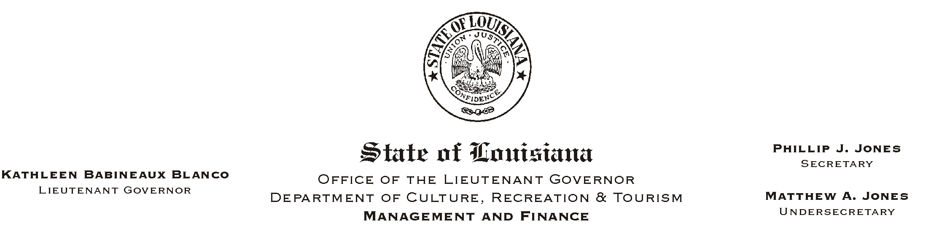

HUMAN RESOURCES MEMORANDUM NO. 03-105

December 29, 2003

TO: Lt. Governor, Secretary, Undersecretary, Assistant Secretaries, Deputy Assistant Secretaries, Program Managers

FROM: Mary F. Ginn
Human Resources Director

SUBJECT: OGB Optional Life Insurance Rates Increase January 1, 2004

A blast fax from the Office of Group Benefits (OGB) was sent to offices last week announcing a rate increase effective January 1, 2004, for those who carry the optional life insurance. Prudential Life Insurance, the provider of our optional life program, is raising its rates 10 percent for the 2004 calendar year.

This rate increase affects only the employee optional life portion. The dependent life and personal accident insurance (PAI) rates will remain unchanged.

Because the OGB announcement occurred in the pay period in which the second January premium is deducted, all employees with optional life will be automatically “one timed” for the increase in premiums which was due during the first pay period.

Copies of the new rates are attached. For those receiving this memo via e-mail prior to receiving a hardcopy, you may visit the OGB web site at www.groupbenefits.org and click on the Agency section to download the spreadsheet.

If you have any questions regarding this rate increase, please contact Marilyn Joseph or Dave Besse in our Human Resources Office at (225) 342-0880.

Attachments

Please Post and Circulate

