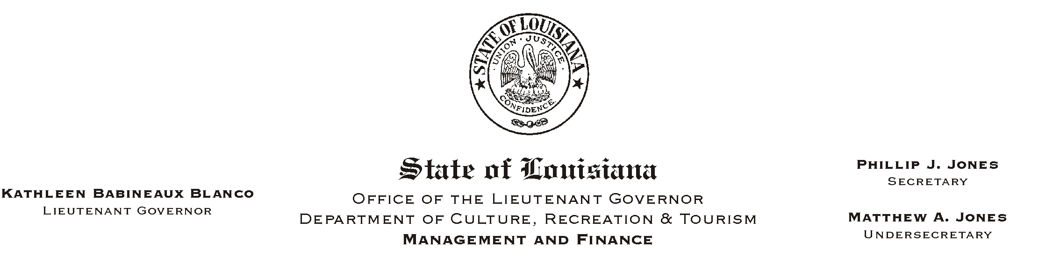

HUMAN RESOURCES MEMORANDUM NO. 03-106

December 29, 2003

TO: Lt. Governor, Secretary, Undersecretary, Assistant Secretaries, Deputy Assistant Secretaries, Program Managers

FROM: Mary F. Ginn
Human Resources Director

SUBJECT: OGB Announces Public Hearing on January 7, 2004 and
Sale of Ochsner Health Plan

OGB PUBLIC HEARING

Proposed Health Care Benefit Changes for the 2004-05 Plan Year
January 7, 2004, 6-7:30 p.m.
State Police Training Academy Auditorium
7901 Independence Blvd., Baton Rouge

Proposed changes to be discussed include: (1) Eliminating the wild card option, so you will no longer be able to change plans after the beginning of the plan year; and (2) Adding a $1 million lifetime maximum for the MCO (managed care option).

OGB also announces the pending sale of Ochsner Health Plan to Humana, Inc. which was recently made public in the news media. The sale will undergo review by the Insurance Commissioner as well as several other regulatory agencies, including the Federal Trade Commission.

According to OGB, Ochsner Health Plan members should see no change in their coverage or providers. Health care will continue to be provided by OHP physicians as part of a long-term agreement following the sale of OHP to Humana. Ochsner Clinic Foundation will retain ownership of all its other entities, including Ochsner Hospital and 25 clinic locations throughout southern Louisiana.

OGB also states that OHP plan members will eventually have broader options, products, and services and will experience no reduction in the delivery of medical services. OHP members will receive additional information on the pending sale at a later date.

Please Post and Circulate

