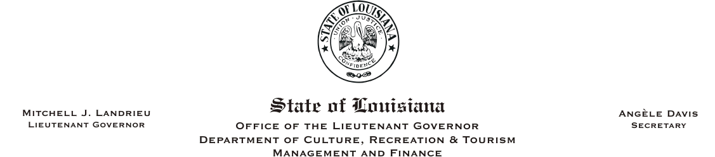
HUMAN RESOURCES MEMORANDUM NO. 05-005

TO: Lt. Governor, Secretary, Assistant Secretaries, Deputy Assistant Secretaries, and Program Managers
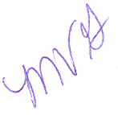
FROM: Mary V. Gloston
Human Resources Director

SUBJECT: Administrative Job Study

DATE: January 21, 2005

Governor Kathleen Blanco approved the Administrative Job Study with an effective date of January 17, 2005. The Human Resources Office is currently in the process of allocating positions based on the position descriptions you submitted in November 2004. We are contacting those offices who have not submitted position descriptions or those who require further discussion. We will send final job title and AS level information to you on your specific positions. Remember, this is a job study; employees will not receive increases in pay unless they are below established minimums of the pay level. Employees who may currently be at the maximum of the pay range may be eligible for merit increases when the anniversary date arrives.

Please direct any questions to Jan Ramezan at 225-342-0880.

MVG:cm

Please Post and Circulate

