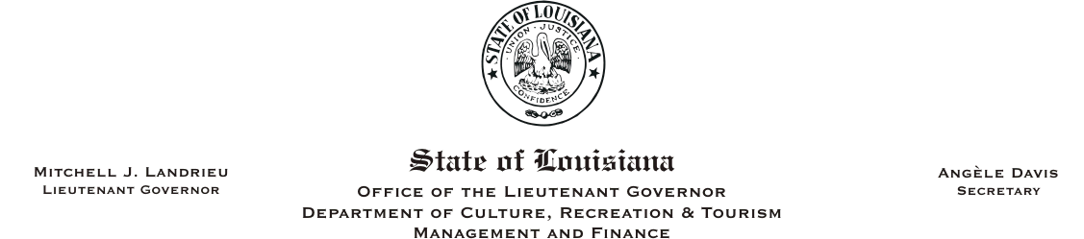
HUMAN RESOURCES MEMORANDUM NO. 05-006

TO: All CRT Employees
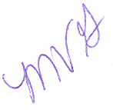
FROM: Mary V. Gloston
Human Resources Director

SUBJECT: Use of Personnel Records – General Circular No. 001598

DATE: January 21, 2005

This is to notify you of receipt of Civil Service General Circular No. 001598 regarding Use of Personnel Records.

As stated in the general circular, automated record-keeping systems contain vast quantities of personal data about employees. This is a reminder to agencies that those individuals who have access to employee information, whether through an automated record-keeping system, paper system or through any other means, have an obligation to use the data only for official governmental business purposes. There is some concern that some individuals who have access to employee data may not have a full understanding of the importance of disseminating information properly in response to requests for public records. An example is that everyone may not know that certain items, such as social security numbers, are private and must be deleted from information prior to dissemination.

This is also a reminder that official employee records are maintained in Human Resources only. While you may retain a copy for your own individual files, the official records are maintained here. It is my recommendation that you keep minimal employee information, as this information may be a potential for subpoena if legal action ensues.

In the near future, the Human Resources Office will establish policy regarding public records and will make this information available to all department employees. General Circular No. 001598 may be accessed at www.dscs.state.la.us. If you have any questions, please feel free to contact me.

MVG:cm

Please Post and Circulate

