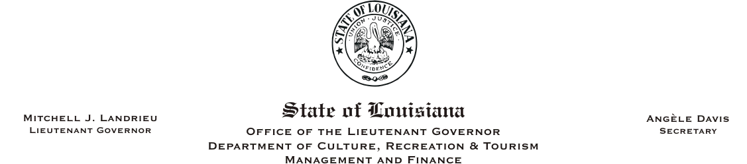
HUMAN RESOURCES MEMORANDUM NO. 05-027

TO: Lt. Governor, Secretary, Undersecretary, Assistant Secretaries, Deputy Assistant Secretaries, and Directors
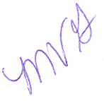
FROM: Mary V. Gloston
Human Resources Director

SUBJECT: HR Policy #2E-0116, Flexible Special Entrance Rates

DATE: August 12, 2005

Attached you will find HR Policy #2E-0116, Flexible Special Entrance Rates, effective July 25, 2005. Special Entrance Rates have been approved for the positions reflected on the spreadsheet attached to the policy. Special Entrance Rates are used when there is a shortage of qualified applicants or a shortage of applicants who have just the bare minimum qualifications. The only positions identified as having such at this time are those reflected on the spreadsheet.

As a reminder, employee salaries are not adjusted unless they fall below the new Special Entrance Rate. Only one employee in the Office of State Library required an adjustment due to the implementation of this policy. The salary adjustment is effective the same date as the policy, July 25, 2005.

If you have any questions, please do not hesitate in contacting me.

MG:cm
Attachment
c: Personnel Liaisons

Please Post and Circulate

