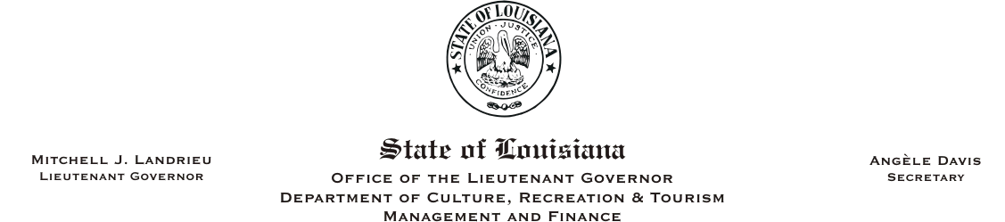
HUMAN RESOURCES MEMORANDUM NO. 05-033

TO: Lt. Governor, Secretary, Undersecretary, Secretary, Assistant Secretaries, Deputy Assistant Secretaries, and Program Managers
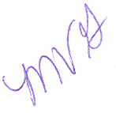
FROM: Mary V. Gloston
Human Resources Director

SUBJECT: Student Status Updates

DATE: September 19, 2005

This is a reminder that student employees are required to verify their full-time student status at the beginning of the spring and fall semesters in order to retain eligibility for State employment.

Please Post and Circulate

Please have each student in your department update an Application For Student Employment and obtain school certification. Certified applications should be returned to the Human Resources Office no later than October 3, 2005. Applications can be downloaded at http://www.dscs.state.la.us, go to “HR Info Center” located on the left-hand side of the page, and then click on “Downloadable Forms.”

If you have any questions, please contact the Human Resources Office at (225) 342-0880.

MVG:JR:cm

Please Post and Circulate

