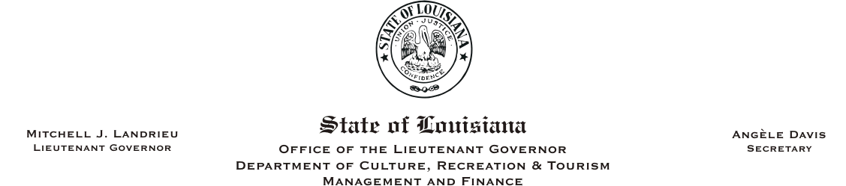
HUMAN RESOURCES MEMORANDUM NO. 05-034

TO: Lt. Governor, Secretary, Assistant Secretaries, Deputy Assistant Secretaries, and Program Managers
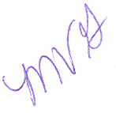
FROM: Mary V. Gloston
Human Resources Director

SUBJECT: Civil Service General Circular No. 001623 – Hurricane Katrina – Special Leave and Overtime

DATE: September 22, 2005

During the past three weeks, agencies have been inundated with information, directives, and questions regarding employment status, leave status, payment, overtime, rules and regulations as it affects our state employees.

Please Post and Circulate

I have sent to you several pieces of information relative to these topics, but I believe the best information and direction we have received yet, regarding special leave and overtime, are included in this general circular. I am attaching a chart summarizing the subject areas of this general circular and the information that is of most importance to our employees. Please ensure that you notify your employees of information that is applicable to them. While Civil Service rules remain in effect and some exceptions have been made, this agency still has its policies in effect. If you feel you need an exception to an agency policy, please discuss with me to ensure we are not in violation of any other policies/rules.

Please direct any questions you may have regarding General Circulars No. 001620 and 001623 on assigning employees and special leave/overtime to Human Resources.

Again, thank you for your cooperation and assistance.

MG:cm
Attachment

