HUMAN RESOURCES MEMORANDUM NO. 06-006

TO: Lt. Governor, Secretary, Undersecretary, Assistant Secretaries, Deputy Assistant Secretaries, Program Managers and Directors
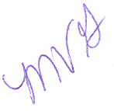
FROM: Mary V. Gloston
Human Resources Director

SUBJECT: Fiscal Year 2004/2005 Optional Pay Adjustments/Rewards and Recognition
Reports

DATE: February 1, 2006

This is to inform you that the Fiscal Year 2004/2005 reports for employees receiving optional pay adjustments and rewards and recognition adjustments are available for your review. Hard copy reports will be sent to you under separate cover.

Please make this information available to all of your employees.

MVG:cm
c: Personnel Liaisons

Please Post and Circulate

