HUMAN RESOURCES MEMORANDUM NO. 06-008

TO: All CRT Employees
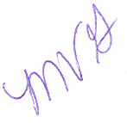
FROM: Mary V. Gloston
Human Resources Director

SUBJECT: 2005 Annual Member Account Statements

DATE: March 2, 2007

LASERS will be mailing 2005 Annual Member Statements at the beginning of this month to all employees that are members.

Please Post and Circulate

To ensure that you receive your retirement information, please keep your address current with Human Resources. If a change of address is needed, please submit a change of address form to Human Resources, or you may log onto LEO and update this information yourself.

If you have any questions regarding your Annual Member Statement, please contact Kathy Merrill at (225) 342-0880.

MVG:KM:cm

