HUMAN RESOURCES MEMORANDUM NO. 06-015

TO: Lt. Governor, Secretary, Undersecretary, Assistant Secretaries, Deputy Assistant Secretaries, Program Managers and Directors
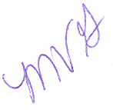
FROM: Mary V. Gloston
Human Resources Director

SUBJECT: Fiscal Year 2005/2006 Optional Pay Adjustments/Rewards and Recognition
Reports

DATE: July 31, 2006

This is to inform you that Fiscal Year 2005/2006 reports for employees receiving optional pay adjustments and rewards and recognition adjustments are attached for your review.

Please make this information available to all of your employees.

MVG:cm
c: Personnel Liaisons

Please Post and Circulate

